Tattle Tale Analytics Dashboard — Detailed Project Report
Project type: Data analytics dashboard / community impact analytics application
Domain: UK not-for-profit community art organisation
Role positioning: Data Analyst / Analytics Engineer / Big Data Analyst portfolio project
Technology stack: Python, Flask, Jinja2, Plotly, HTML, CSS, JavaScript, Flask-Mail, python-dotenv
Data approach: Synthetic data only for privacy-safe demonstration
Repository readiness: Suitable for GitHub project documentation, LinkedIn portfolio post, and CV project section

1. Executive Summary
The Tattle Tale Analytics Dashboard is a Flask-based analytics and reporting dashboard designed for a UK-based, not-for-profit community art organisation. The organisation provides free creative workshops and community activities, so the dashboard is deliberately focused on community impact, participation, engagement, feedback, accessibility, and support activity rather than commercial performance.
The project converts a public-facing art community website into a more complete web application by adding a protected analytics dashboard. The dashboard uses deterministic synthetic data to demonstrate how a real community organisation could monitor activity without exposing private participant data. This makes the project safe for client demonstration, GitHub publishing, LinkedIn showcasing, and CV use.
The dashboard includes KPI cards, interactive Plotly visualisations, community growth analytics, workshop participation analysis, support breakdowns, survey-based insights, art medium interest analysis, participant feedback summaries, age group analytics, and a workshop impact table. The final dashboard language avoids payment, sales, profit, revenue, and currency-based metrics because the organisation does not charge users for workshops.
From a data analyst perspective, the project demonstrates the full analytics delivery workflow: understanding client context, defining suitable KPIs, creating privacy-safe data, transforming raw synthetic records into dashboard-ready structures, building interactive charts, integrating backend data with a frontend template, validating wording for stakeholder suitability, and presenting insights in a non-technical format.

2. Project Background and Client Context
Tattle Tale is represented in this project as a community-led art organisation that supports creative participation through free workshops and events. The project context is important because a standard business dashboard would normally include revenue, sales, customer conversion, paid bookings, or profit/loss indicators. Those metrics are not suitable here.
For this organisation, the meaningful questions are different:
- How many people is the organisation reaching?
- How many people are actively participating?
- Are free workshop places being used effectively?
- Which workshops and art mediums are most popular?
- How do members discover the organisation?
- What feedback are participants giving?
- Which age groups are being reached?
- What type of non-financial support helps the organisation continue its work?
- How can the organisation communicate community impact to stakeholders, partners, funders, volunteers, or trustees?
The dashboard was therefore designed as a community impact analytics dashboard. It is not a sales reporting tool. Its purpose is to help a non-technical client understand participation patterns, engagement trends, workshop reach, support activity, and feedback outcomes.

3. Project Objectives
The project objectives were:
- Build a protected analytics dashboard inside the existing Flask web application.
- Use synthetic data to protect privacy and avoid exposing real participant records.
- Present analytics in a format suitable for a non-technical client demonstration.
- Replace business-style metrics with community impact metrics.
- Create interactive charts that explain engagement, participation, growth, support, and feedback.
- Provide an evidence-style dashboard that could support future community reporting.
- Maintain the existing website design and application structure while adding a dedicated analytics layer.
- Demonstrate data analyst skills including KPI design, data modelling, dashboard design, visual analytics, stakeholder communication, and privacy-aware reporting.

4. Scope of Work

4.1 Included in Scope
The completed project includes:
- Flask web application structure.
- Public-facing website routes.
- Demo admin login flow.
- Protected dashboard route under /dashboard/.
- Synthetic data generation module.
- Plotly chart factory module.
- Jinja2 dashboard template.
- KPI card section.
- Interactive charts.
- Workshop impact table.
- JSON API endpoints for dashboard data and KPI data.
- Privacy-safe reporting using fictional records.
- Community-focused dashboard terminology.
- Email-enabled feedback and survey routes through Flask-Mail.
- Passenger WSGI entry point for shared hosting style deployment.

4.2 Excluded from Scope
The current project does not include:
- A production-grade user management system.
- A live relational database.
- Real participant records.
- Payment processing.
- Sales analytics.
- Financial reporting.
- Production-grade authentication and authorisation.
- Automated CI/CD pipeline.
- Distributed big data infrastructure such as Spark, Hadoop, Kafka, or cloud data warehouses.
This is important for honest portfolio positioning. The project is best described as a data analytics dashboard and analytics engineering project, not as a large-scale distributed big data system. However, it is still highly relevant for data analyst and junior analytics roles because it demonstrates dashboard delivery, data transformation, visualisation, stakeholder alignment, and privacy-aware analytics.

5. Technology Stack
The project uses the following technologies confirmed from the codebase:
Area | Technology | Purpose
Backend framework | Python Flask | Main web application and routing
Templating | Jinja2 | Rendering dynamic dashboard values into HTML
Dashboard charts | Plotly | Interactive visual analytics
Frontend | HTML, CSS, JavaScript | Dashboard UI and public website pages
Email handling | Flask-Mail | Contact, feedback, and survey email delivery
Environment configuration | python-dotenv | Loading .env configuration values
Hosting entry | Passenger WSGI | Deployment compatibility with Passenger-based hosting
Styling | Custom CSS | Dark analytics dashboard design and website styling
Data | Synthetic Python-generated data | Privacy-safe analytics demonstration
The requirements.txt file includes:
Flask
Flask-Mail
python-dotenv
plotly

6. Application Architecture
The application is organised as a Flask project with a separate dashboard package.
tattle_project/
└── flask_project/
├── app.py
├── passenger_wsgi.py
├── requirements.txt
├── dashboard/
│ ├── __init__.py
│ ├── dashboard_routes.py
│ ├── synthetic_data.py
│ └── charts.py
├── templates/
│ ├── dashboard.html
│ ├── login.html
│ ├── index.html
│ ├── community-survey.html
│ ├── event-booking.html
│ ├── faq.html
│ ├── privacy-policy.html
│ └── other frontend templates and JavaScript assets
└── static/
├── css/
├── images/
└── videos/

6.1 Main Application Layer — app.py
The app.py file is the main Flask application entry point. It performs the following responsibilities:
- Creates the Flask application instance.
- Loads environment variables using python-dotenv.
- Configures the Flask secret key.
- Registers the dashboard blueprint.
- Defines public website routes.
- Implements a demo admin login and logout flow.
- Configures Flask-Mail.
- Handles feedback, survey, and contact form submissions.
- Serves selected JavaScript files from the templates directory.
- Runs the application locally with debug=False on port 5000.

6.2 Dashboard Blueprint — dashboard_routes.py
The dashboard is implemented as a Flask Blueprint with the URL prefix /dashboard. This is a clean architectural choice because it separates dashboard logic from the main website routes.
The blueprint provides three main routes:
Route | Purpose
/dashboard/ | Renders the main analytics dashboard
/dashboard/api/data | Returns all generated dashboard data as JSON
/dashboard/api/kpis | Returns KPI summary data as JSON
The dashboard route calls the synthetic data generator, creates all Plotly chart HTML snippets, and passes the resulting data objects into the dashboard.html template.

6.3 Data Generation Layer — synthetic_data.py
The synthetic_data.py module acts as the dashboard’s data layer. Instead of pulling from a live database, it creates deterministic synthetic datasets using Python functions and a fixed seed value.
This layer is responsible for generating:
- KPI summary data.
- Community member growth trends.
- Workshop participation records.
- Event/activity records.
- Survey response data.
- 90-day engagement time series.
- Community support breakdown data.
- Content performance data.
The fixed seed value (seed_value=42) ensures the generated numbers remain stable during demonstrations. This makes the dashboard consistent when refreshed, which is useful for client presentation and portfolio screenshots.

6.4 Visualisation Layer — charts.py
The charts.py module acts as a chart factory. It receives dashboard data and converts it into Plotly figures. Each chart function creates one visualisation and converts it into embeddable HTML using plotly.io.to_html().
The chart module defines a consistent dark theme using shared colour constants, layout defaults, font settings, grid colours, hover labels, and legend styles. This avoids inconsistent chart styling and gives the dashboard a professional analytics product feel.

6.5 Presentation Layer — dashboard.html
The dashboard.html template is the user-facing analytics dashboard. It renders:
- Top navigation bar.
- Dashboard heading.
- KPI cards.
- Chart cards.
- Plotly chart HTML snippets.
- Workshop impact table.
- Logout/admin session display.
- Responsive layout and dashboard styling.
The dashboard uses Jinja2 expressions to insert values such as KPI numbers, chart HTML, and workshop records into the page.

7. Data Flow
The dashboard follows a clear analytics data pipeline:
Synthetic Data Functions
↓
Aggregated Dashboard Data Dictionary
↓
Plotly Chart Factory Functions
↓
Dashboard Flask Route
↓
Jinja2 Template Rendering
↓
Browser-Based Interactive Dashboard
Detailed flow:
- The user logs in through the demo admin login page.
- The user opens /dashboard/.
- The dashboard blueprint checks the session for admin_logged_in.
- get_all_dashboard_data(seed_value=42) generates all synthetic datasets.
- generate_all_charts(data) creates eight Plotly charts.
- The route passes KPIs, chart HTML, workshop records, event records, and content performance data to dashboard.html.
- The dashboard page renders KPI cards, charts, and the workshop table.
- Plotly handles interactive chart behaviour in the browser.

8. Privacy and Synthetic Data Strategy
The project uses synthetic data only. This was a deliberate privacy and ethics decision.

8.1 Why Synthetic Data Was Used
Real community data may include personal information such as names, contact details, workshop attendance, survey answers, demographics, and feedback. Using real data in a portfolio project would create privacy risk and could conflict with GDPR-style data protection expectations.
Synthetic data solves this by allowing the dashboard to demonstrate realistic analytics without exposing any real records.

8.2 Synthetic Data Characteristics
The data is fictional but designed to feel realistic for a small UK community art organisation. It includes plausible ranges such as:
Data area | Example synthetic range or values
Total community members | 500 to 2,500
Active participants | 30% to 50% of total members
Free workshops delivered | 20 to 150
Community support hours | 300 to 2,000
Survey responses | 80 to 700
Workshop capacity | 10 to 30 participants
Completion rate | 70% to 98%
Community rating | 4.1 to 4.9
Engagement window | 90 days
Growth window | 12 months

8.3 Ethical Positioning
The dashboard avoids:
- Real participant names.
- Real personal data.
- Real workshop records.
- Real feedback content.
- Real financial figures.
- Any payment or paid attendance information.
This makes the dashboard suitable for demonstration, portfolio presentation, and GitHub publication.

9. Dashboard KPI Design
The dashboard uses five primary KPI cards. These are designed to give a quick executive-level summary of community activity.

9.1 Total Community Members
Purpose: Shows the overall size of the community represented by the platform.
Generated from: generate_kpi_summary() in synthetic_data.py.
Current seeded value: 1,809 members.
Analytical value: Helps the organisation understand total community reach and track audience growth over time.

9.2 Active Participants
Purpose: Shows how many members are actively engaging with the organisation.
Generated from: A percentage of total members, using a random range of approximately 30% to 50%.
Current seeded value: 582 active participants.
Analytical value: More useful than total membership alone because it indicates active participation, not just registration or awareness.

9.3 Free Workshops Delivered
Purpose: Shows how many free workshops have been delivered.
Current seeded value: 90 workshops.
Analytical value: Demonstrates delivery output and practical community service. This is especially relevant for reporting community value to stakeholders.

9.4 Community Support Hours
Purpose: Shows non-financial support effort such as volunteer or community support time.
Current seeded value: 509 hours.
Analytical value: Replaces unsuitable financial metrics with a meaningful community resource indicator.

9.5 Community Feedback Received
Purpose: Shows the amount of feedback collected from the community.
Current seeded value: 308 responses.
Analytical value: Demonstrates that the organisation listens to participants and can improve programming based on feedback.

10. Dashboard Visualisations
The dashboard contains eight interactive Plotly charts. Each chart is designed for a specific community insight.

10.1 Daily Engagement — 90 Days
Chart type: Multi-line time series with a range slider.
Function: create_engagement_chart()
Data source: generate_engagement_timeseries()
Chart traces:
- Page Views
- Unique Visitors
- Interactions
What it shows:
This chart shows how digital engagement changes over a 90-day period. It separates overall page views from unique visitors and interactions, giving a clearer picture of both reach and behaviour.
Why it matters:
A community organisation needs to know whether people are finding and using the website. If engagement increases around workshop announcements, local events, or campaign activity, the organisation can understand what drives participation.
Data analyst interpretation:
This is a behavioural trend chart. It supports questions such as:
- Are website visits increasing or decreasing?
- Are visitors interacting with the site or only viewing pages?
- Are weekends generating stronger engagement?
- Does digital engagement align with workshop planning cycles?

10.2 Community Growth Over Time
Chart type: Combined area, line, marker, and bar chart.
Function: create_user_growth_chart()
Data source: generate_user_growth()
Chart traces:
- Total Members
- New Members
- Returning Participants
- Inactive Members
What it shows:
This chart shows the monthly development of the community over a 12-month period. It combines total community size with new member growth, returning participants, and inactive members.
Why it matters:
For a community project, growth is not only about sign-ups. Returning participants show whether people continue to value the activities. Inactive members help identify where re-engagement may be needed.
Data analyst interpretation:
This chart supports retention and engagement analysis without using commercial terms such as acquisition funnel, monetisation, or churn. It is stakeholder-friendly and suitable for non-technical users.

10.3 Community Support Breakdown
Chart type: Stacked area chart.
Function: create_community_support_chart()
Data source: generate_community_support_data()
Chart traces:
- Volunteer Hours
- Donated Materials
- Grant-Supported Sessions
- Partner Support
- Community Outreach Support
What it shows:
This chart explains the non-financial support behind the organisation’s free activities. Instead of showing money, it shows types of support that help the organisation deliver community work.
Why it matters:
The client does not charge users, so financial charts would be misleading. This chart presents a more accurate view of how the organisation is supported.
Data analyst interpretation:
This chart is a redesigned metric model. The original business-style insight was replaced with a community value model. It demonstrates the ability to align analytics with stakeholder context.

10.4 Free Workshop Participation
Chart type: Horizontal overlay bar chart.
Function: create_workshop_chart()
Data source: generate_workshop_data()
Chart traces:
- Available Places
- Participants
What it shows:
This chart compares the number of available places for each workshop against the number of participants. It also displays average rating labels on the participant bars.
Why it matters:
It helps the organisation understand which workshops are close to capacity and which may need additional outreach.
Data analyst interpretation:
This chart is a capacity utilisation visual. It supports planning decisions such as whether to repeat a workshop, increase available places, or improve promotion for lower-participation activities.

10.5 How Members Discover Us
Chart type: Donut chart.
Function: create_discovery_donut()
Data source: generate_survey_data()
Categories:
- Word of Mouth
- Community Partners
- Social Media
- Local Events
- School / College Referral
- Website
What it shows:
This chart shows the channels through which people discover the organisation.
Why it matters:
A community organisation often relies on local networks, partner organisations, schools, colleges, social media, and word of mouth. This chart helps identify which channels are most effective.
Data analyst interpretation:
This is an outreach effectiveness chart. It can guide where staff or volunteers should focus communication efforts.

10.6 Art Medium Interest Distribution
Chart type: Radar chart.
Function: create_medium_radar()
Data source: generate_survey_data()
Categories:
- Painting
- Drawing
- Textiles
- Photography
- Mixed Media
- Digital Art
- Sculpture
What it shows:
This chart visualises participant interest across different creative mediums.
Why it matters:
It helps the organisation plan future workshops based on community interests.
Data analyst interpretation:
The radar chart is suitable because it compares multiple categories in a compact way. It shows whether demand is balanced across art forms or concentrated in a few areas.

10.7 Participant Feedback Summary
Chart type: Bar chart / rating distribution.
Function: create_ratings_chart()
Data source: generate_survey_data()
Scale: 1-star to 5-star experience ratings.
What it shows:
This chart summarises how participants rate their experience.
Why it matters:
Community feedback is one of the strongest non-financial indicators of quality. It helps the organisation understand participant satisfaction and identify areas for improvement.
Data analyst interpretation:
The distribution can reveal whether ratings are consistently positive or whether there are issues at lower rating levels that need attention.

10.8 Community Reach by Age Group
Chart type: Bar chart.
Function: create_age_chart()
Data source: generate_survey_data()
Age groups:
- 18-24
- 25-34
- 35-44
- 45-54
- 55-64
- 65+
What it shows:
This chart shows age group distribution across the synthetic survey responses.
Why it matters:
For a community art organisation, accessibility and inclusion are important. Age-group insight helps show whether activities are reaching a broad community.
Data analyst interpretation:
This chart can support inclusive programme planning. If some age groups are underrepresented, the organisation can adjust outreach or workshop design.

11. Workshop Impact Table
The dashboard includes a workshop-level impact table. This table provides a detailed view of individual workshop performance.

11.1 Table Columns
Column | Meaning
Workshop | Name of the synthetic workshop
Medium | Art category linked to the workshop
Enrolled / Capacity | Participants compared with available places
Completion Rate | Percentage of participants completing the workshop
Community Rating | Average participant experience rating
Free Places Delivered | Number of free places used by participants

11.2 Example Workshop Names
The synthetic workshop names are community-focused:
- Community Painting Circle
- Beginner Drawing Workshop
- Textile Art for Wellbeing
- Youth Creative Studio
- Mixed Media Makers
- Digital Art Introduction
- Photography Walk
- Family Craft Session

11.3 Analytical Value
This table helps answer practical operational questions:
- Which workshops are most attended?
- Which workshops have high completion rates?
- Which workshops receive strong community ratings?
- Are workshop places being used effectively?
- Which art mediums attract stronger participation?
- Which activities should be repeated or expanded?

12. Public Website and Supporting Features
The dashboard is part of a larger Flask website. The application includes multiple public routes:
Route | Purpose
/ | Homepage
/about-lana | About page
/community-survey | Community survey page
/turtle-tales-story | Story page
/workshop-chapters | Workshop information page
/event-booking | Event booking/activity page
/faq | Frequently asked questions
/privacy-policy | Privacy information
/contact | Contact anchor route
The presence of these routes means the analytics dashboard is not isolated. It is connected to a broader community website structure.

13. Form Handling and Communication Features
The application includes backend endpoints for handling community communication.

13.1 Feedback Endpoint — /api/feedback
This endpoint accepts JSON feedback data. It validates required fields, checks for a honeypot spam field, creates an email message, and sends it through Flask-Mail.
Fields handled include:
- Rating
- Help status
- Email
- Message
- Submission timestamp

13.2 Community Survey Endpoint — /api/community-survey
This endpoint accepts a JSON dictionary of survey answers. It formats answers into a readable email structure and supports both single-value and list-style answers.

13.3 Contact Endpoint — /api/contact
This endpoint accepts form data containing name, email, and message. It sends a contact form email when mail credentials are configured.

13.4 Data Analyst Relevance
These endpoints show how qualitative and quantitative community feedback could be collected in a real application. In a future version, these submissions could be stored in a database and connected directly to the analytics dashboard.

14. Authentication and Access Control
The dashboard uses a demo login system. The login route accepts any valid-format email address and any non-empty password. On successful login, it stores session values:
session['admin_logged_in'] = True
session['admin_email'] = email
The dashboard blueprint uses a before_request guard to redirect unauthenticated users to the login page.

14.1 Current Purpose
This is suitable for demonstration because it prevents the dashboard from being directly accessible without login during local usage.

14.2 Production Limitation
This is not production-grade authentication. For real deployment, the project would need:
- Password hashing.
- User database.
- Role-based access control.
- Strong session security.
- CSRF protection.
- Login rate limiting.
- Secure password reset workflow.
This limitation should be clearly stated in GitHub documentation to avoid overstating the project.

15. Dashboard Design and User Experience
The dashboard uses a dark analytics interface with card-based layout. The design choices support readability and professional presentation.

15.1 UI Characteristics
- Dark background.
- Gradient accents.
- KPI cards.
- Chart cards.
- Responsive grid layout.
- Clean typography.
- Interactive Plotly charts.
- Hover states and subtle animation.
- Admin topbar with navigation.
- Workshop table for detailed records.

15.2 Stakeholder-Friendly Language
The dashboard wording is intentionally non-technical and community-friendly. For example:
Business-style wording avoided | Community-focused wording used
Revenue | Community Support Hours
Sales | Free Places Delivered
Profit | Community Impact
Paid bookings | Participants / Available Places
Customer reviews | Participant Feedback
Churn | Inactive Members
This language change is not cosmetic. It is a key analytics design decision because dashboard metrics must match the organisation’s mission.

16. Screenshots and Visual Evidence
The following screenshots can be included in the GitHub README or LinkedIn project post. They should be stored in a repository folder such as docs/screenshots/ or assets/screenshots/.

Screenshot 1 — Dashboard Overview and KPI Cards
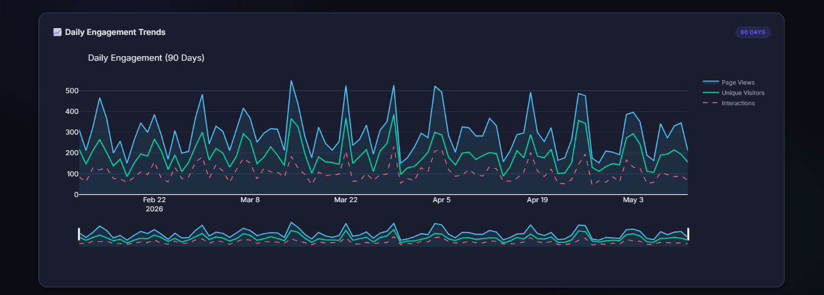
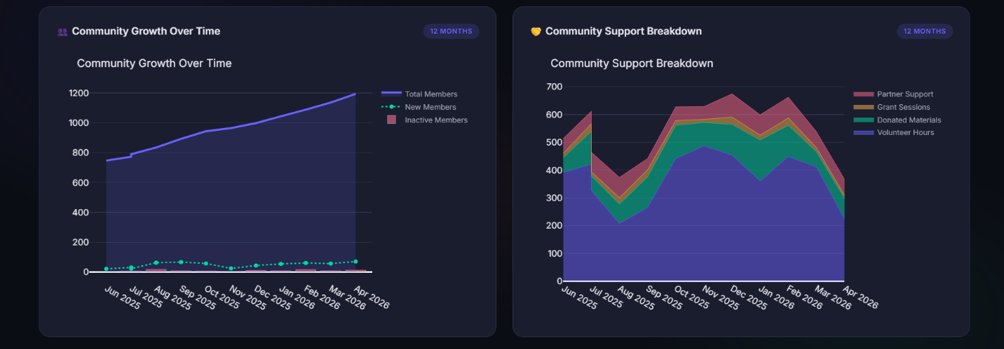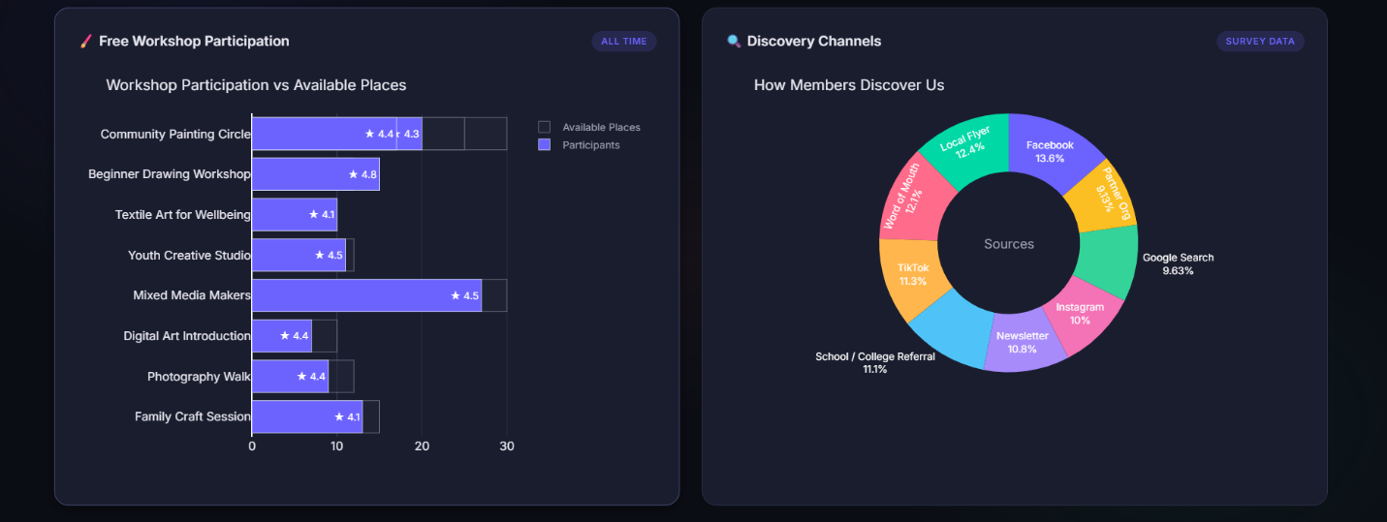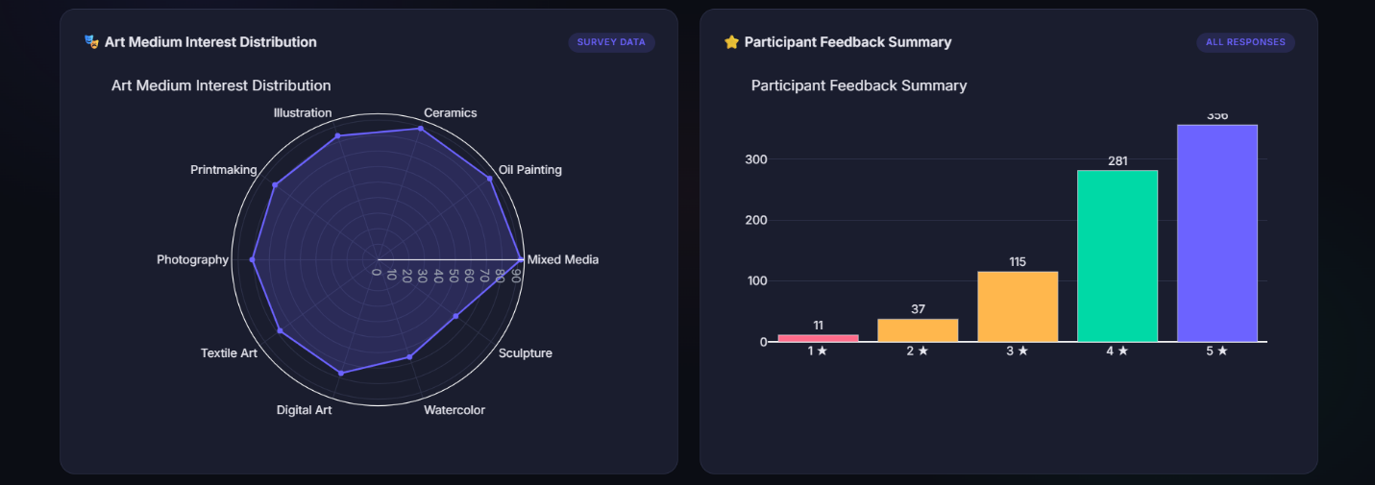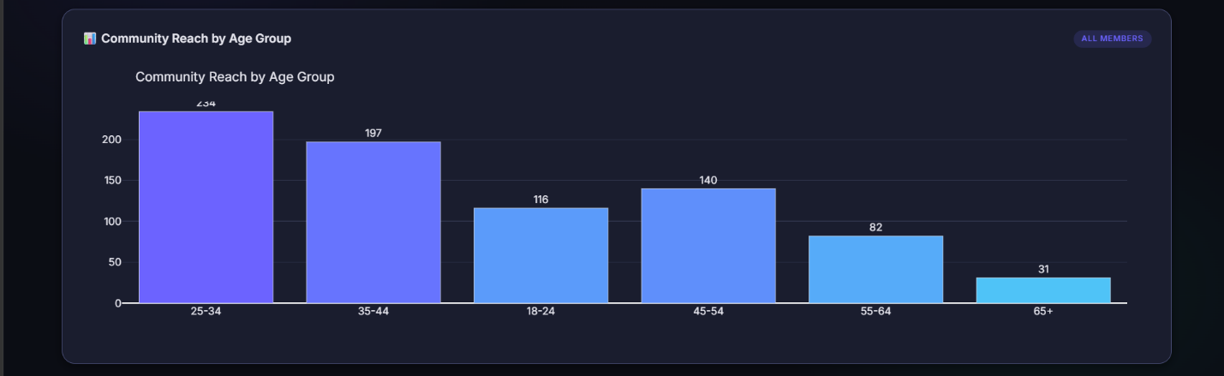

Dashboard overview and KPI cards
What this screenshot demonstrates:
- Professional dashboard landing section.
- Community-focused KPI cards.
- Removal of financial metrics.
- Clear admin dashboard navigation.
- Client-friendly analytics summary.

Screenshot 2 — Charts and Workshop Impact Table
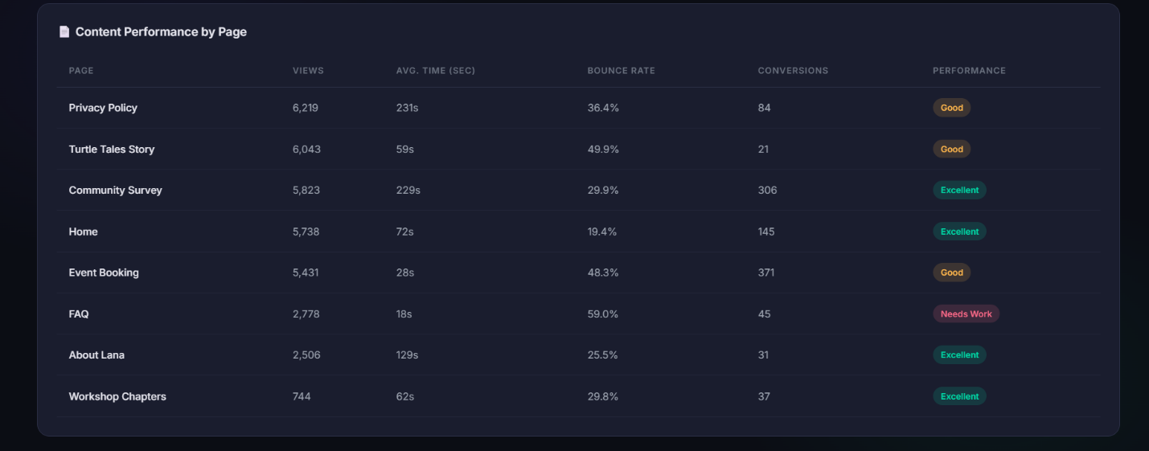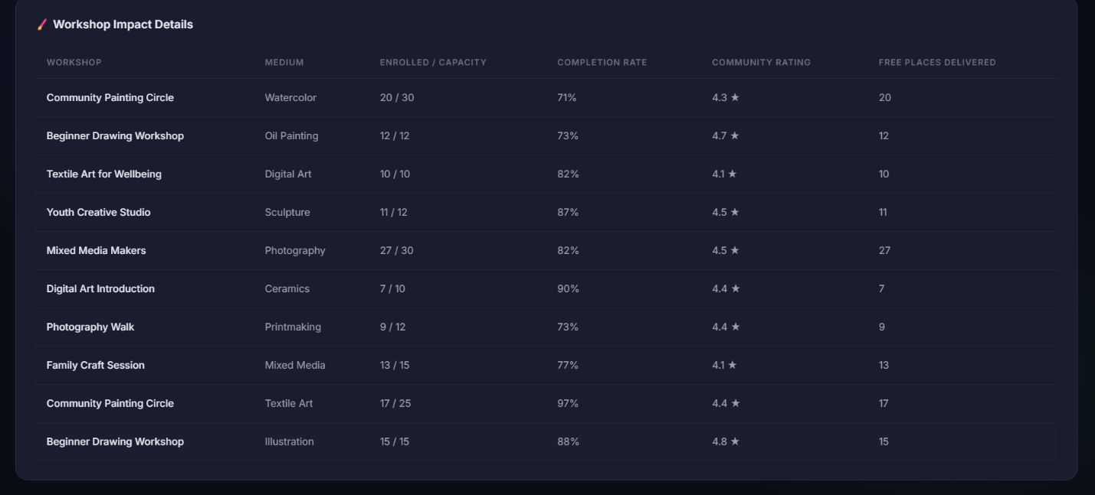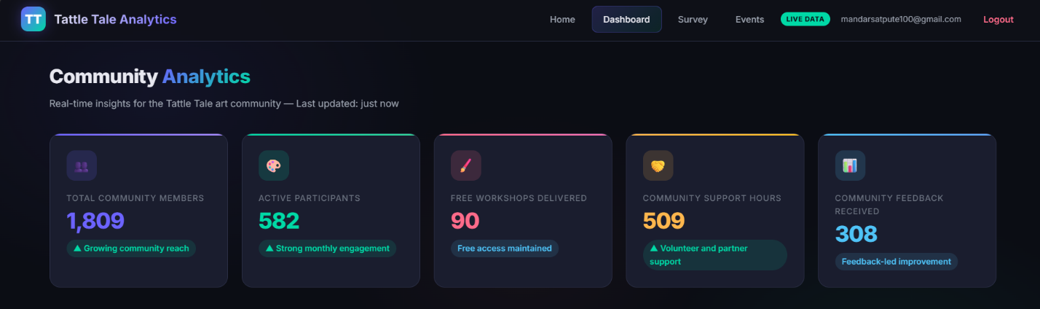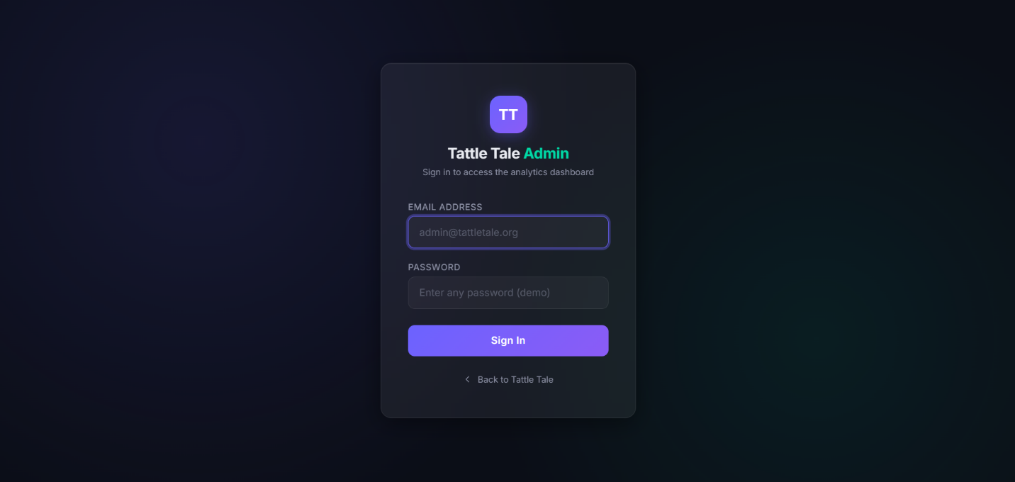
Dashboard charts and workshop table
What this screenshot demonstrates:
- Community support breakdown.
- Workshop participation visualisation.
- Participant feedback and age group analysis.
- Workshop impact table.
- Non-financial, community-focused insight design.

Recommended Additional Screenshots to Add
For GitHub and LinkedIn, add these extra screenshots if possible:
- Login page.
- Full dashboard top section.
- Community Growth Over Time chart.
- Community Support Breakdown chart.
- Free Workshop Participation chart.
- Participant Feedback Summary chart.
- Workshop Impact Details table.
- Mobile or responsive dashboard view.
Suggested GitHub folder structure:
docs/
└── screenshots/
├── 01-dashboard-overview.png
├── 02-community-growth.png
├── 03-community-support-breakdown.png
├── 04-workshop-participation.png
├── 05-feedback-summary.png
└── 06-workshop-impact-table.png

17. Implementation Work Performed
The main work completed in this project includes:

17.1 Backend Development
- Built and configured a Flask application.
- Registered a dashboard blueprint.
- Created route handlers for website pages.
- Added a demo admin login and logout workflow.
- Added JSON API endpoints for dashboard data.
- Added feedback and survey email submission routes.
- Configured environment variables through .env and python-dotenv.
- Included Passenger WSGI support for deployment compatibility.

17.2 Data Engineering and Data Modelling
- Designed synthetic datasets to represent community activity.
- Used seeded random generation for reproducible demonstration data.
- Created separate generator functions for KPIs, growth, workshops, survey responses, engagement, support data, and content performance.
- Created realistic synthetic value ranges for a small UK community organisation.
- Modelled community support without using financial values.
- Structured data dictionaries for direct chart generation and template rendering.

17.3 Dashboard Analytics
- Created community-focused KPI cards.
- Built eight interactive Plotly charts.
- Added community growth analysis.
- Added 90-day engagement time series.
- Added free workshop participation analysis.
- Added community support breakdown.
- Added discovery channel analysis.
- Added art medium interest analysis.
- Added participant feedback summary.
- Added age group reach analysis.
- Added workshop impact table.

17.4 Insight Redesign
- Removed inappropriate commercial dashboard framing.
- Replaced financial-style metrics with community impact metrics.
- Reframed support activity in non-financial terms.
- Used stakeholder-friendly wording for non-technical users.
- Ensured dashboard labels match a free not-for-profit community project.

17.5 UI and Presentation
- Built a dark-themed analytics dashboard page.
- Used card-based KPI layout.
- Embedded Plotly charts into the Jinja2 template.
- Maintained responsive design principles.
- Used visual hierarchy to separate overview KPIs, charts, and detailed table data.

18. Validation and Quality Checks
The following technical checks were performed on the uploaded project version:

18.1 Python Syntax Check
The Python files were compiled using py_compile to confirm there were no syntax errors in:
- app.py
- dashboard/__init__.py
- dashboard/charts.py
- dashboard/dashboard_routes.py
- dashboard/synthetic_data.py

18.2 Data Generation Check
The synthetic data pipeline was executed successfully using get_all_dashboard_data(seed_value=42).
The seeded KPI output was:
KPI | Value
Total Community Members | 1,809
Active Participants | 582
Free Workshops Delivered | 90
Community Feedback Received | 308
Community Support Hours | 509
Average Rating | 4.2
Engagement Rate | 65.5%
Retention Rate | 64.0%

18.3 Chart Generation Check
The chart generation function returned all expected chart keys:
user_growth
workshops
community_support
discovery
engagement
medium_radar
ratings
age_demographics
This confirms the chart factory is aligned with the data dictionary structure.

18.4 Record Count Check
The seeded synthetic dataset generated:
- 10 workshop records.
- 8 event/activity records.
- Survey response distribution based on 400 generated synthetic responses.
- 90 days of engagement data.
- 12 months of growth data.
- 12 months of community support data.

18.5 Dashboard Language Check
The dashboard-facing language was aligned with a not-for-profit community context. Financial language was avoided in the final dashboard concept. The dashboard focuses on:
- Community members.
- Active participants.
- Free workshops.
- Community support hours.
- Feedback received.
- Free places delivered.
- Workshop participation.
- Community support breakdown.

19. Challenges and Solutions

Challenge 1 — Avoiding Real Data While Still Demonstrating Analytics
Problem: The dashboard needed to look realistic, but real participant data could not be used.
Solution: Synthetic data generators were created with plausible ranges, categories, and seeded reproducibility.

Challenge 2 — Making the Dashboard Suitable for a Free Community Organisation
Problem: Business dashboards often focus on sales, payments, revenue, and profit. These metrics do not fit a free community workshop model.
Solution: Metrics were reframed around community impact, participation, support hours, free places, feedback, and accessibility.

Challenge 3 — Keeping Insights Non-Technical
Problem: Analytics dashboards can become difficult for non-technical stakeholders to interpret.
Solution: Chart titles, labels, and KPI names were written in plain language, such as “Community Growth Over Time” and “Free Workshop Participation”.

Challenge 4 — Integrating Charts into Flask Templates
Problem: Interactive charts needed to be generated in Python and displayed in an HTML template.
Solution: Plotly figures were converted into embeddable HTML snippets and passed through the Flask route into the Jinja template.

Challenge 5 — Maintaining a Consistent Design
Problem: Multiple charts can look inconsistent if each uses separate styling.
Solution: A shared colour palette and layout defaults were defined in charts.py.

20. Business and Community Value
Although this is not a commercial dashboard, it provides strong operational value for a community organisation.

20.1 Value for the Organisation
The dashboard helps the organisation:
- Understand community reach.
- Monitor active participation.
- Track free workshop delivery.
- Identify popular workshops.
- Understand how people discover the organisation.
- Analyse participant feedback.
- Review age-group reach.
- Evidence community support activity.
- Prepare impact narratives for stakeholders.
- Make better programme planning decisions.

20.2 Value for Stakeholders
For trustees, partners, volunteers, funders, or community leaders, the dashboard provides a clear evidence-style view of activity and outcomes.

20.3 Value for Participants
Indirectly, the dashboard supports participants by helping the organisation improve workshops, understand demand, and maintain free access.

21. Data Analyst Skills Demonstrated
This project demonstrates the following data analyst and analytics engineering skills:

21.1 Requirements Understanding
The project shows the ability to understand client context and avoid unsuitable metrics. A not-for-profit community organisation needs different KPIs from a commercial organisation.

21.2 KPI Design
The dashboard defines KPIs around community reach, active participation, free workshop delivery, support hours, and feedback.

21.3 Data Modelling
The synthetic data is structured into separate entities: KPIs, members, workshops, events, surveys, engagement, support, and content performance.

21.4 Data Transformation
Generated data is transformed into chart-ready structures such as lists, ordered dictionaries, time series, and category distributions.

21.5 Data Visualisation
The project uses multiple visual forms: time series, area chart, stacked area chart, horizontal bar chart, donut chart, radar chart, rating bar chart, and demographic bar chart.

21.6 Dashboard Development
The project integrates backend data and frontend presentation using Flask, Jinja2, and Plotly.

21.7 Privacy Awareness
Synthetic data is used to avoid exposing real participant information.

21.8 Stakeholder Communication
The dashboard wording is designed for non-technical users, making insights accessible and presentation-ready.

22. Limitations
The project has clear limitations that should be stated honestly on GitHub or during interviews.
- The data is synthetic and does not represent actual organisational performance.
- The dashboard is a demonstration/prototype rather than a production analytics platform.
- The login system is for demo use and is not production-grade.
- There is no persistent analytics database in the current version.
- The dashboard does not currently support filters for date range, workshop type, location, or participant group.
- There is no automated data ingestion pipeline.
- Survey and feedback submissions are emailed rather than stored in a structured analytics database.
- There is no deployment pipeline or automated testing framework included.
- The project does not use distributed big data technologies; it is better positioned as an analytics dashboard project.
These limitations are acceptable for a portfolio project as long as they are clearly explained.

23. Future Improvements
The project could be extended in several ways:

23.1 Data Storage
- Add PostgreSQL or SQLite database integration.
- Store workshop records, survey responses, and feedback submissions.
- Create database models for participants, workshops, sessions, and feedback.

23.2 Data Pipeline
- Add CSV upload for community data.
- Add scheduled data refresh.
- Add data validation checks.
- Add ETL scripts for transforming raw survey records into dashboard metrics.

23.3 Analytics Features
- Add dashboard filters by date, workshop type, age group, and art medium.
- Add retention cohort analysis.
- Add workshop demand forecasting.
- Add participant segmentation.
- Add geographic reach analysis by city or postcode area using anonymised data.
- Add text analysis for open-ended feedback.

23.4 Reporting Features
- Add downloadable PDF reports.
- Add CSV export.
- Add monthly community impact report generation.
- Add automated email summary for stakeholders.

23.5 Security and Production Readiness
- Implement secure user registration and login.
- Store hashed passwords.
- Add CSRF protection.
- Add role-based access control.
- Add secure deployment configuration.
- Add logging and monitoring.

23.6 Deployment
- Deploy on Render, Railway, PythonAnywhere, or a cloud platform.
- Add environment-based configuration.
- Add production WSGI server setup.
- Add GitHub Actions for basic checks.

24. Recommended GitHub README Structure
For GitHub, the project should be presented with a concise but detailed README.
Recommended sections:
# Tattle Tale Analytics Dashboard
## Overview
## Project Context
## Key Features
## Dashboard Screenshots
## Technology Stack
## Data Privacy and Synthetic Data
## Dashboard Insights
## Project Architecture
## How to Run Locally
## Validation Performed
## Limitations
## Future Improvements
## CV / Portfolio Summary

Suggested GitHub Short Description
A Flask and Plotly analytics dashboard for a UK not-for-profit community art organisation, using synthetic data to visualise community growth, free workshop participation, support hours, engagement, feedback, and accessibility insights.

Suggested GitHub Topics
python
flask
plotly
data-analytics
dashboard
data-visualization
synthetic-data
community-impact
analytics-engineering
portfolio-project

25. LinkedIn Project Description
Use this version for a LinkedIn post or project section:
I built a Flask-based analytics dashboard for a UK not-for-profit community art project, focused on community impact rather than financial metrics.
The dashboard uses synthetic data for privacy-safe demonstration and visualises key insights such as total community members, active participants, free workshops delivered, community support hours, feedback received, workshop participation, discovery channels, art medium interest, participant ratings, and age-group reach.
The project includes a protected dashboard route, Python-based synthetic data generation, interactive Plotly charts, Jinja2 template rendering, community-focused KPI cards, and a workshop impact table.
This project helped me demonstrate practical data analyst skills including KPI design, data modelling, synthetic data generation, dashboard development, visual storytelling, privacy-aware reporting, and stakeholder-friendly insight design.

26. CV Project Entry
Use this version in your CV:
Tattle Tale Analytics Dashboard | Python, Flask, Plotly, Jinja2, HTML/CSS
- Built a privacy-safe analytics dashboard for a UK not-for-profit community art organisation using synthetic data.
- Designed community-focused KPIs covering total members, active participants, free workshops delivered, community support hours, and feedback responses.
- Developed interactive Plotly charts to analyse community growth, workshop participation, support breakdown, digital engagement, discovery channels, art medium interest, participant feedback, and age-group reach.
- Integrated Python-generated synthetic datasets with Flask routes and Jinja2 templates to deliver a client-ready dashboard interface.
- Reframed business-style metrics into community impact insights suitable for non-technical stakeholders and portfolio demonstration.
For a shorter CV version:
Created a Flask and Plotly community impact dashboard using synthetic data to visualise free workshop participation, community growth, support hours, feedback, and demographic reach for a UK not-for-profit art organisation.

27. Interview Talking Points
When explaining this project in a UK data analyst interview, use these points:
- The client context shaped the KPI design. Because the organisation provides free workshops, I avoided sales and financial metrics.
- I used synthetic data to protect privacy and make the project safe for public portfolio use.
- I designed the dashboard around community impact: reach, participation, feedback, workshop usage, and support.
- I separated the project into data generation, chart generation, routing, and template rendering layers.
- I used Plotly to create interactive visualisations and embedded them into a Flask dashboard.
- I validated the Python files and confirmed chart generation works from the synthetic data structure.
- I would improve the project by adding a database, secure authentication, dashboard filters, and downloadable reports.

28. File-by-File Technical Summary
File | Lines | Purpose
app.py | 224 | Main Flask app, public routes, login/logout, mail configuration, feedback/survey/contact endpoints
dashboard/dashboard_routes.py | 53 | Dashboard blueprint, authentication guard, dashboard route, dashboard JSON APIs
dashboard/synthetic_data.py | 246 | Synthetic data generation for KPIs, members, workshops, events, survey, engagement, support, and content performance
dashboard/charts.py | 328 | Plotly chart factory module with shared dark theme and eight chart functions
templates/dashboard.html | 708 | Main dashboard UI template with KPI cards, chart cards, and workshop impact table
templates/login.html | 265 | Demo admin login page
passenger_wsgi.py | 9 | Passenger WSGI deployment entry point
requirements.txt | 4 | Python dependencies

29. Detailed Route Summary
Route | Method | Function | Description
/ | GET | home() | Renders homepage
/login | GET/POST | login() | Demo admin login
/logout | GET | logout() | Clears session and redirects home
/about-lana | GET | about_lana() | About page
/community-survey | GET | community_survey() | Community survey page
/turtle-tales-story | GET | tattletale_story() | Story page
/workshop-chapters | GET | workshop_chapters() | Workshop information page
/event-booking | GET | event_booking() | Event/activity page
/faq | GET | faq() | FAQ page
/privacy-policy | GET | privacy_policy() | Privacy policy page
/contact | GET | contact() | Returns homepage contact anchor
/api/feedback | POST | handle_feedback() | Handles feedback submissions
/api/community-survey | POST | handle_community_survey() | Handles survey submissions
/api/contact | POST | handle_contact() | Handles contact form submissions
/dashboard/ | GET | dashboard_home() | Renders analytics dashboard
/dashboard/api/data | GET | dashboard_api() | Returns full dashboard JSON data
/dashboard/api/kpis | GET | kpi_api() | Returns KPI summary JSON

30. Final Conclusion
The Tattle Tale Analytics Dashboard is a strong portfolio project for data analyst, junior analytics engineer, and dashboard developer roles. It demonstrates the ability to translate a real stakeholder context into meaningful analytics, create privacy-safe data, build an end-to-end Flask dashboard, design suitable KPIs, and communicate insights clearly to non-technical users.
The most important strength of the project is that it does not force commercial metrics onto a non-commercial organisation. Instead, it adapts the analytics model to the mission of the organisation: free creative participation, community reach, support, feedback, and inclusion.
For GitHub and LinkedIn, the project should be positioned as:
A privacy-safe Flask and Plotly community impact analytics dashboard using synthetic data to visualise participation, engagement, workshop delivery, community support, feedback, and demographic reach for a UK not-for-profit art organisation.
This is a credible, job-relevant project because it shows technical development, data thinking, stakeholder understanding, and ethical handling of data.

